Sharing to you the Success Factors Integration SFAPI/Odata Tools. This tool can help you in building your query and in viewing sample entity records.

Link: <https://sfapitoolsflms.hana.ondemand.com/SFIntegration/>

Select **\*\*Improved** OData Query Tool - Graphical OData Query Builder**

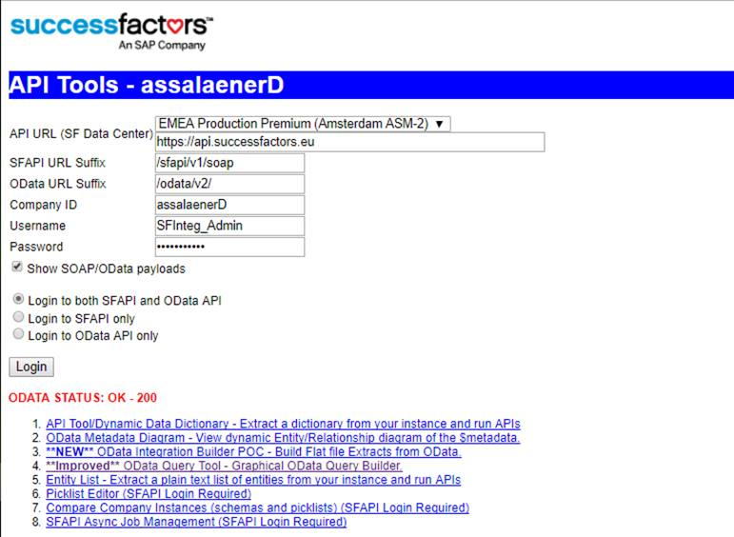

**Sample Output**

